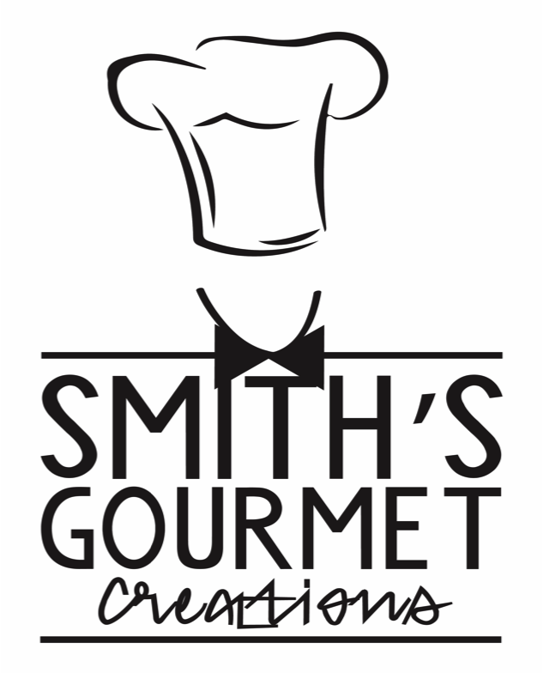
Brunch Menu

Mini Blackened Salmon Cakes $5 pp
Served with Lemon Yum-Yum Sauce
Garlic Butter Shrimp & Grits $5 pp
Ultimate Shrimp & Grits $6 pp
Garlic Shrimp, Turkey Sausage, Tomatoes, Caramelized Onions, Applewood Smoked Bacon, green onions served atop of Creamy Monterey Jack Cheddar Grits and Garlic Butter Sauce
FULLY Loaded Grits $6 pp
Andouille Sausage, Turkey Sausage, Tomatoes, Caramelized Onions, Applewood Smoked Bacon, green onions served atop of Creamy Monterey Jack Cheddar Grits and Andouille Sausage Cajun Cream Sauce
Buttermilk Fried Chicken & Waffles $5 pp
Served with Bourbon & Vanilla infused Syrup
Jerk Chicken & Waffles $5 pp
Spicy Honey Fried Chicken & Waffles
Chicken or Shrimp Pesto Linguine $4 pp
Honey Fried Chicken Benedict $5 pp
Spinach & Cheddar Mini Frittata, Cajun Cream Sauce & Buttermilk Biscuit
Mini Assorted Frittatas $3 pp
Toppings: onions, spinach, tomato, cheddar, mushroom, or peppers
Philly Cheese Steak Frittata $4 pp
Biscuits & Herb Sausage Gravy $3 pp
Delicious sausage and herb gravy over buttermilk biscuits
Herb Potato Hash $2 pp
with herb potatoes, Spicy Andouille Sausage, Caramelized onions and peppers with sunny side eggs
Mixed Berry French toast $4 pp
Classic French toast with assorted mixed berries
Seasonal Fruit Platter $2 pp
Seasonal Fruit Salad Martinis $2.50 pp
Parfaits $2 pp
Strawberries & Blue Berries mixed with yogurt and granola
Mimosa Bar $10 pp
Assorted fruit served with Champagne and delicious juices

Sides $2 pp
3 Cheese Macaroni +1 pp
Lobster Mac & Cheese +$3 pp
Breakfast Potatoes
Smoked Turkey Collard Greens
Bourbon Sweet Potato Casserole with Candied Pecans and drizzle in honey
Mixed Green Salad with Honey mustard Vinaigrette
New Orleans Style Dirty Rice

A la Carte $1.50 pp
Side of Hickory Smoked Bacon
(Pork or Turkey)
Brown Sugar Bacon
Scrambled Eggs
Cheddar & Spinach Scrambled Eggs
Sausage links
(Pork or Turkey)
Cheesy Grits

**Omelet Station available upon request**

